Exam 2 study guide
Chapter 5
- Describe the anatomical barrier components of the innate immunity.
  - Consists of skin and mucous membranes, which include the mucosal epithelia that line the respiratory, gastrointestinal, and urogenital tracts; synthesize and release peptides and proteins with antimicrobial activity (
  - Skin: antimicrobial peptides, fatty acids in sebum
  - Epidermis and Dermis
    - Epidermis: thin outer layer consisting of keratin
    - Dermis: composed of connective tissue and contains blood vessels, hair follicles, sebaceous glands, and sweat glands.
- How does normal flora assist with resistance to infection?
  - Competes with invading mirobes, fluid/feces expelled from rectum
- What are some of the limitations of anatomical barriers?
  - Breaks in the skin
  - Easily penetrated by biting insects
  - Specialize adaptations
- Describe cells and events/responses that link innate immunity to adaptive immunity.

- What are pattern recognition receptors and what do they detect?

- What are some events that occur during inflammation?
- Describe antimicrobial peptides and give examples.
- Give examples of receptors of the innate immune system and their targets.
- What are toll-like receptors?
- Examples of target ligands for the toll-like receptors.
  - 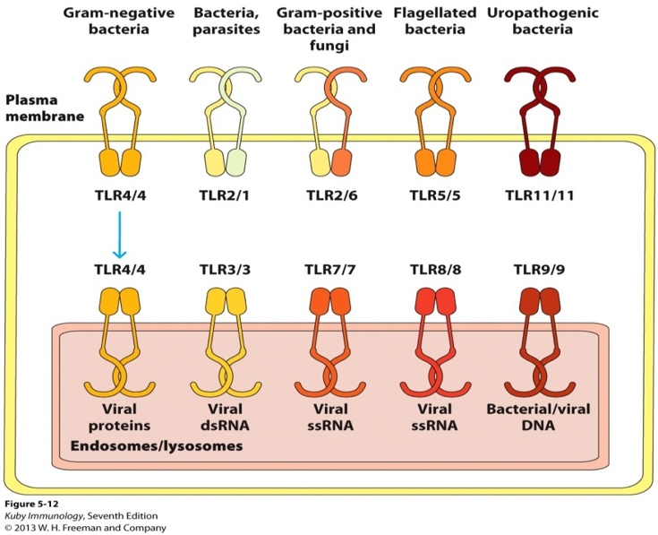
- Discuss the characteristics of the cell types that mediate innate immunity.
- Describe oxidative attack.
  - Employs reactive oxygen species (ROS) and reactive nitrogen species (RNS).
  - Generated by the NADPH phagosome oxidase (phox) enzyme complex
- Describe nonoxidative attack.
  - Defenses are deployed when neutrophil granules fuse with phagosomes.
  - Composed of Bactericidal/permeability-increasing protein, Proteases, Lysozyme, Defensins, and cathelicidins

Chapter 3

- What is vectorial redistribution of the secretory apparatus?
- What are factors that can influence the cell becoming more or less susceptible to the actions of a ligand?
  - Increasing or decreasing the expression of the receptor for that ligand
- Compare and contrast affinity and avidity.
  - Affinity: a strength of that individual pairing
  - Avidity: strength of multiple interactions
  - an interaction may have weak affinity, but high overall avidity
- What are some of the changes in the receptor that occurs once the ligand binds to the receptor?
  - Conformational: shape change
  - Dimerization: formation of a dimer
  - Covalent modification: regulating the activity of a protein (usually an enzyme)
- Understand the importance of having multiple noncovalent bonds between receptor and ligand.

- What is meant by multivalent with respect to antigen and antibody?

- The role of receptor dimerization, receptor multimerization and lipid rafts in signal initiation.
  - Receptor dimerization is often a result in multimerizarion
- Significance and examples of co-receptors and accessory molecules for BCR and TCR.

- What is the need for the Igα/Igβ dimer in BCR signaling?

- What is the difference between mIg and antibody?

- Describe the general structure of an antibody.

- What features do glycosylation of antibody provide?

- Compare and contrast BCR and TCR.

- Role of the CD3 complex.

- Components of the TCR-CD3 complex and their interactions with each other.

- What is the predominant TCR found in the body?

- CD4 and CD8 characteristics.

- Gamma delta T cells characteristics (There were approximately 8 slides discussing these cells)

- CD1 molecule characteristics

- Receptor – ligand affinity rankings.

- T-cell interactions other than that of the TCR and MHC molecule.

